KUBERNETES INSTALLATON ( K8s )

Any Linux machine u can install K8s, so I have AWS account taking one Linux VM.

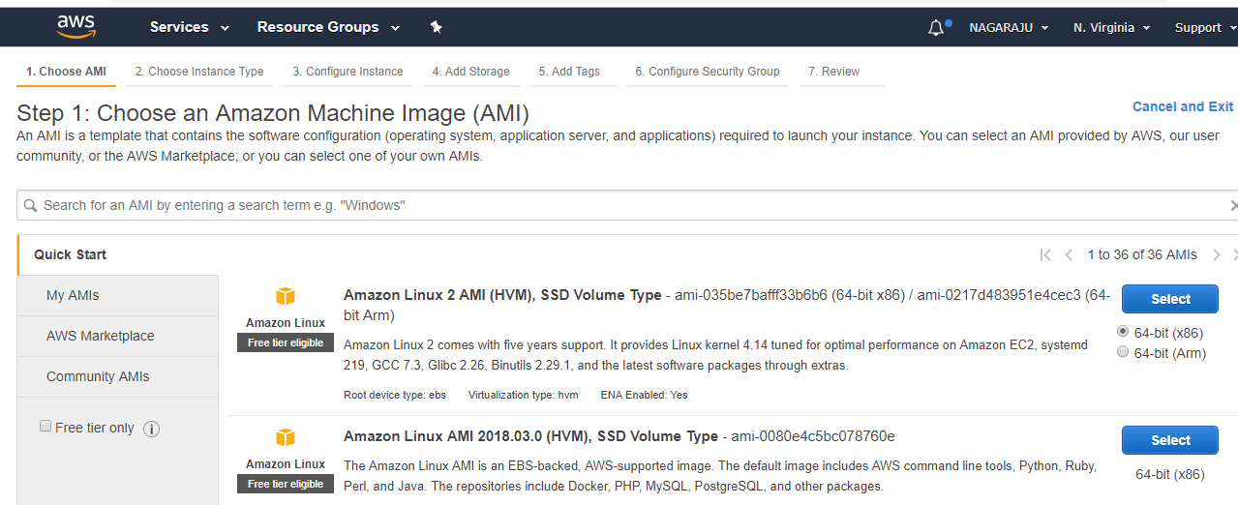

First one I am launching and take t2 Large

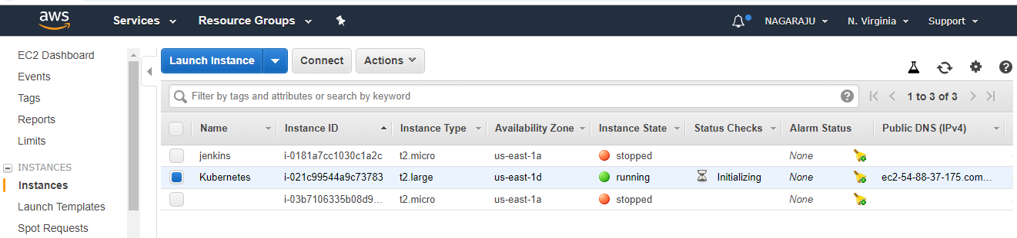

My Linux VM is running

Now I am login to VM

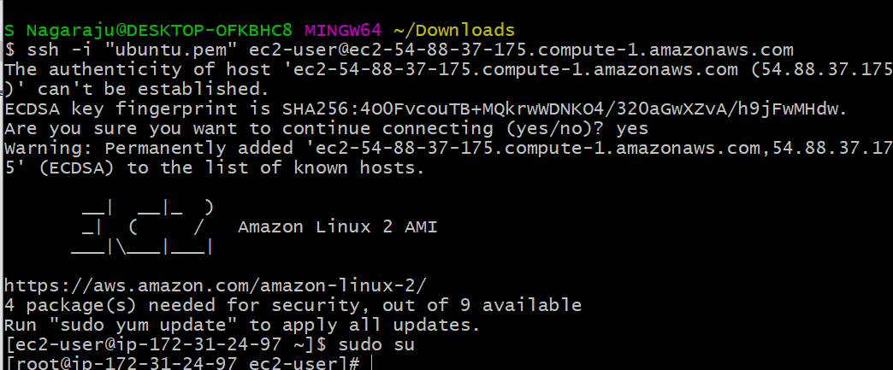

Install kubernetes in Linux VM



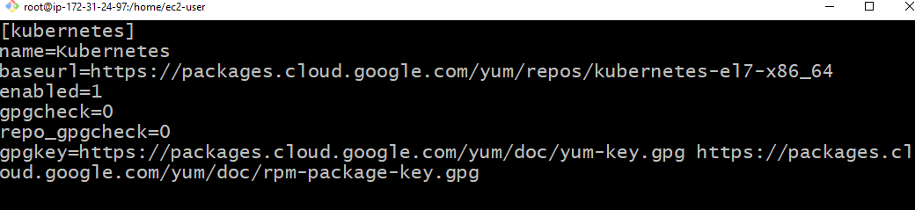

Save it that file

#Install kubelet , kubeadm and Docker



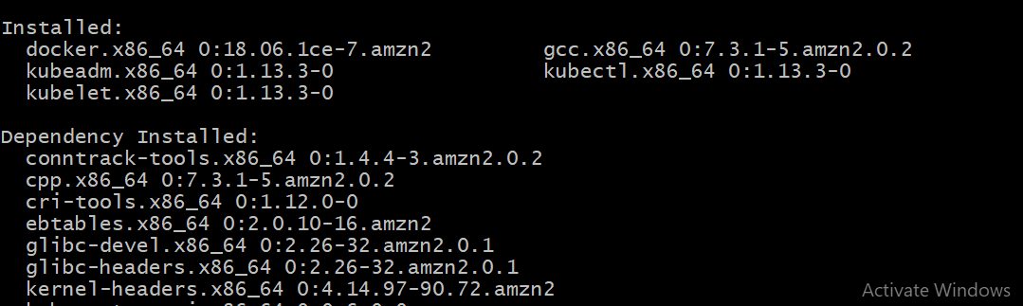

It installs the Kubelet, kubeadm and docker

Now start the service



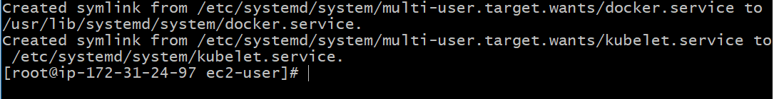

vi /etc/sysctl.d/k8s.conf

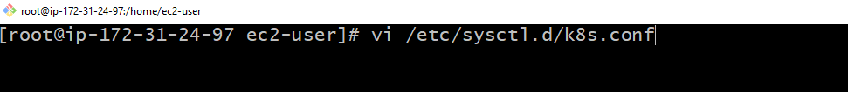

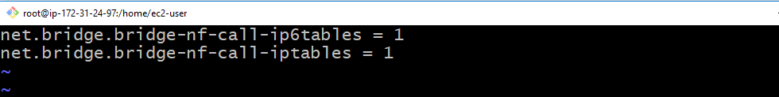

Save the file

#Run following commands

|  |
| --- |
|  |

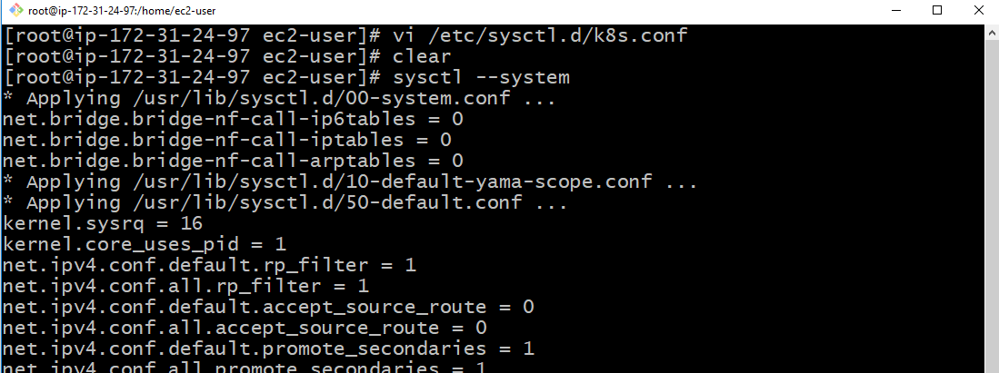







Once file opens it shows KUBELET_EXTRA-ARGS= (REMOVED) AND PASTE



#Restart Kubelet

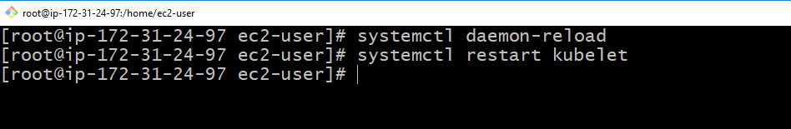

#create cluster

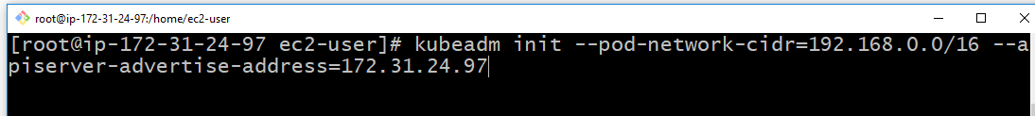

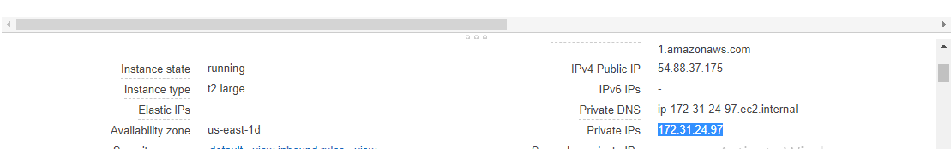

My Private IP is given

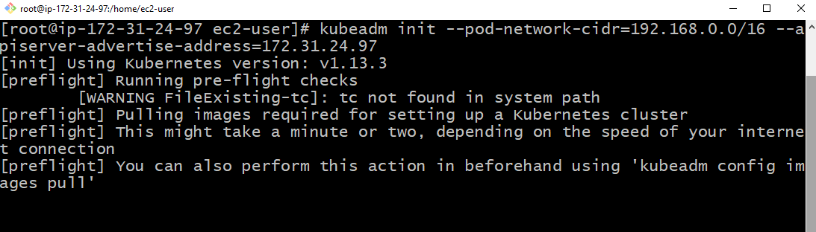

It will install all configuration and certificates

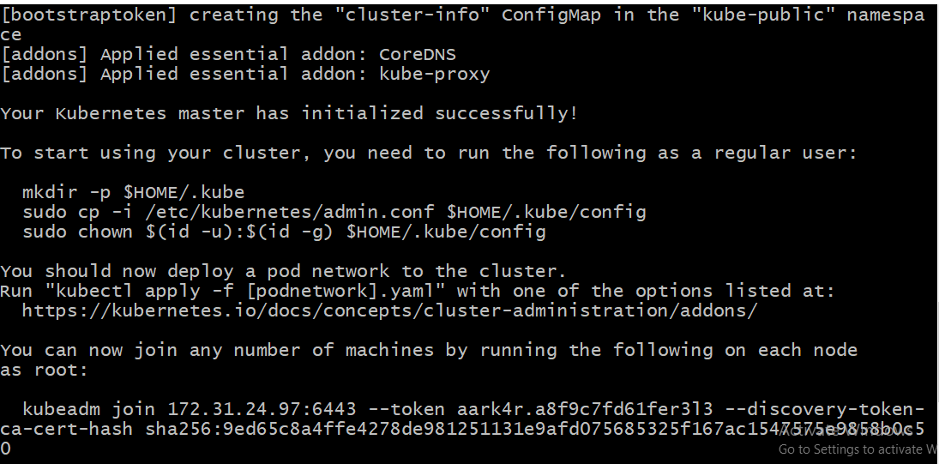

Run the commands

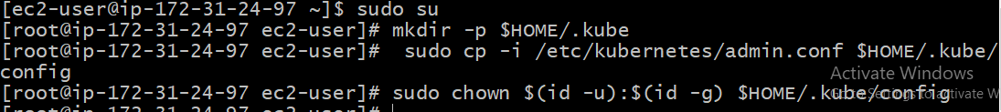

Copy the kubeadm join



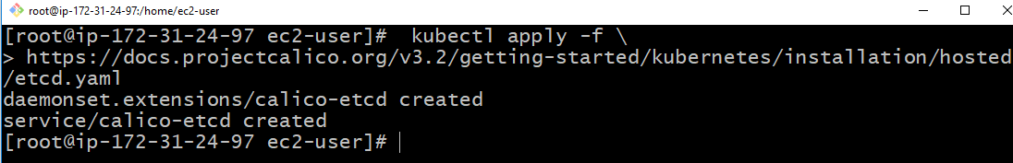

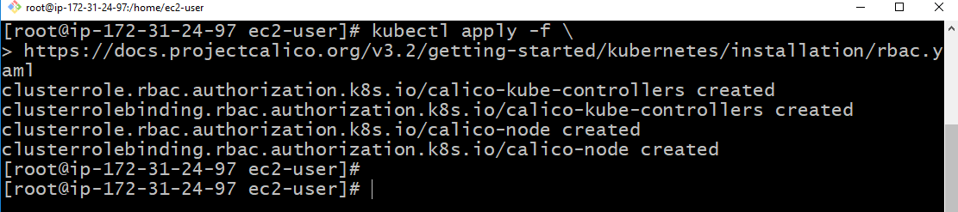

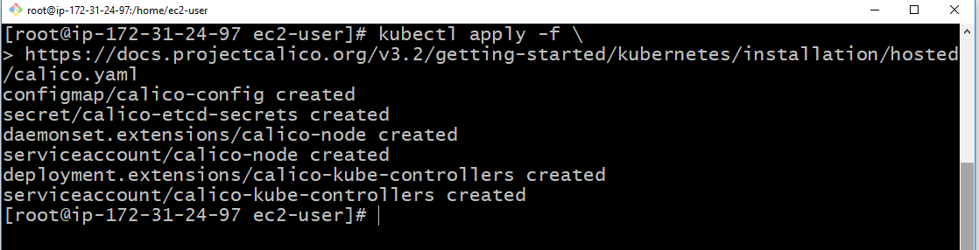

#refer <https://kubernetes.io/docs/tasks/access-application-cluster/web-ui-dashboard/>

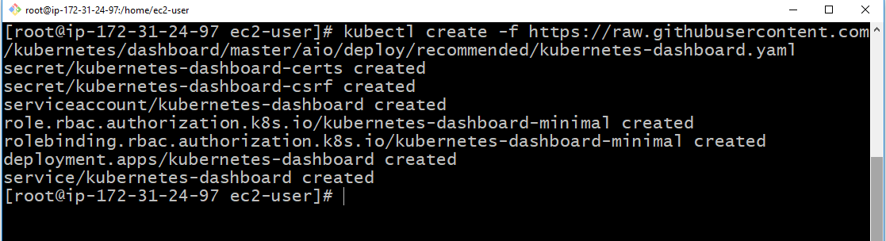

Now check the dashboard

Run this command : kubectl get pods --all-namespaces

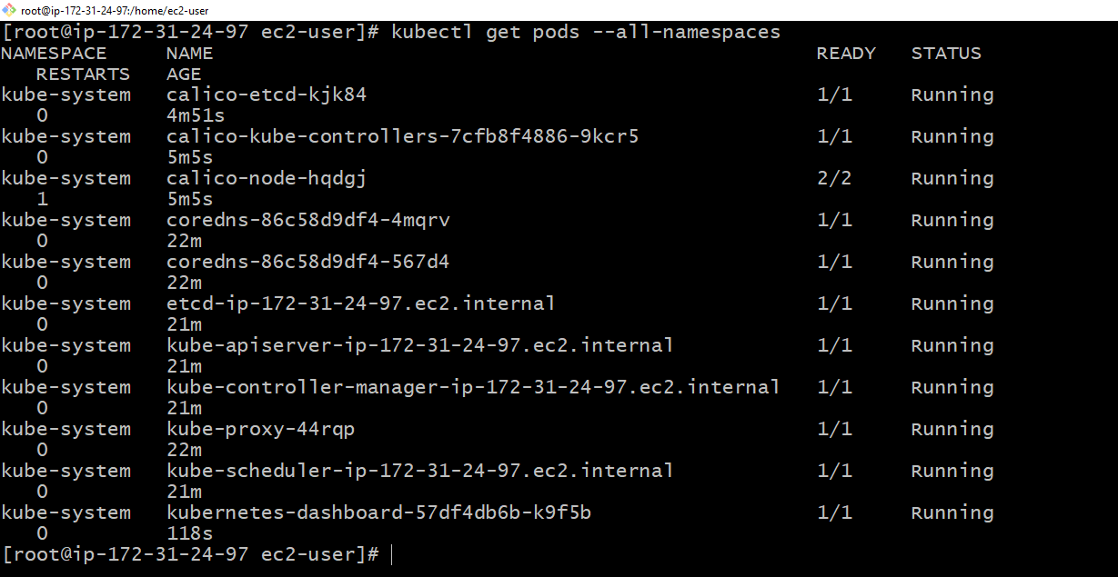

Check all are created and running

vi kube-dashboard-access.yaml

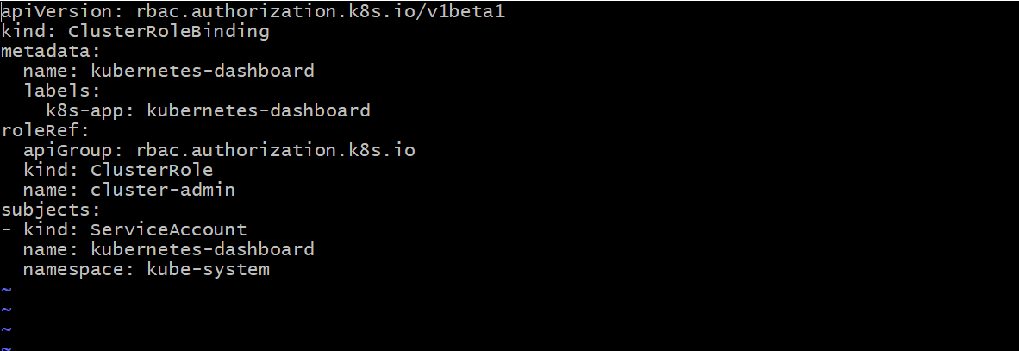

Run this commands



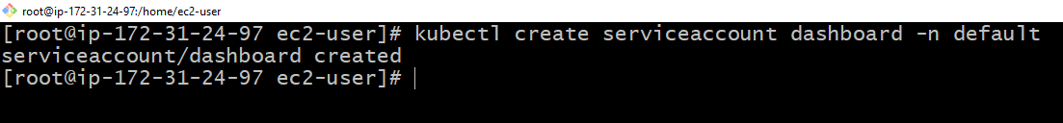

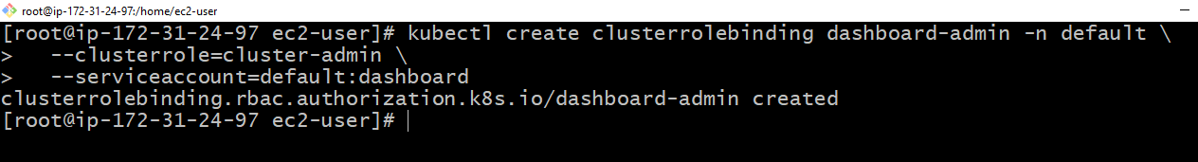

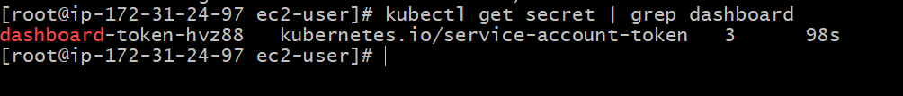

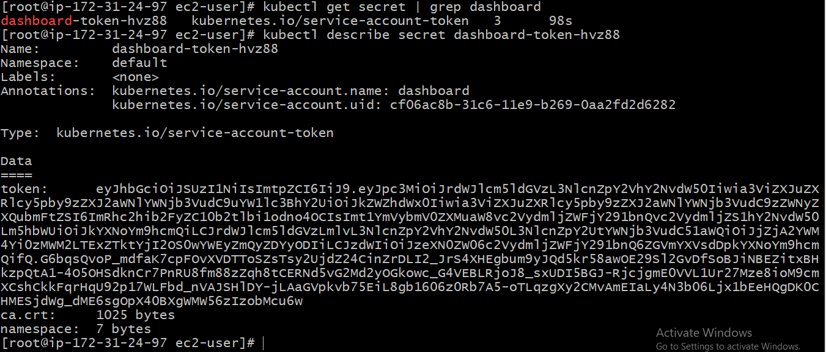

Copy the token one notepad + + file

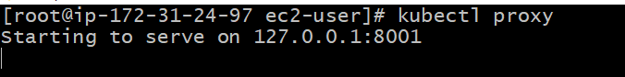

Open one more git bash where u copied u r pem file there open gitbash

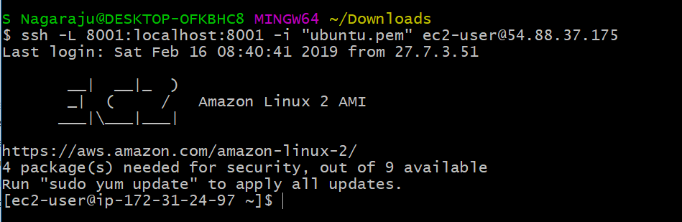

Here I given public Ip address

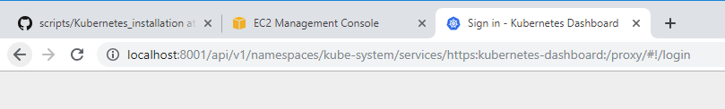

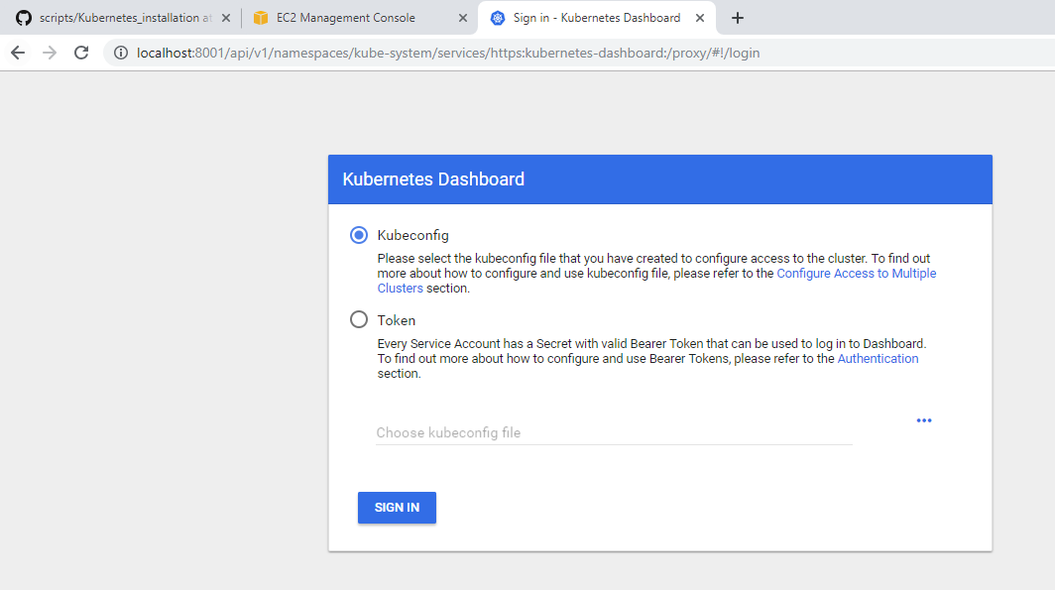

Select token

U copied the notepad + + that token u paste

Now see the kubernetes dashboard

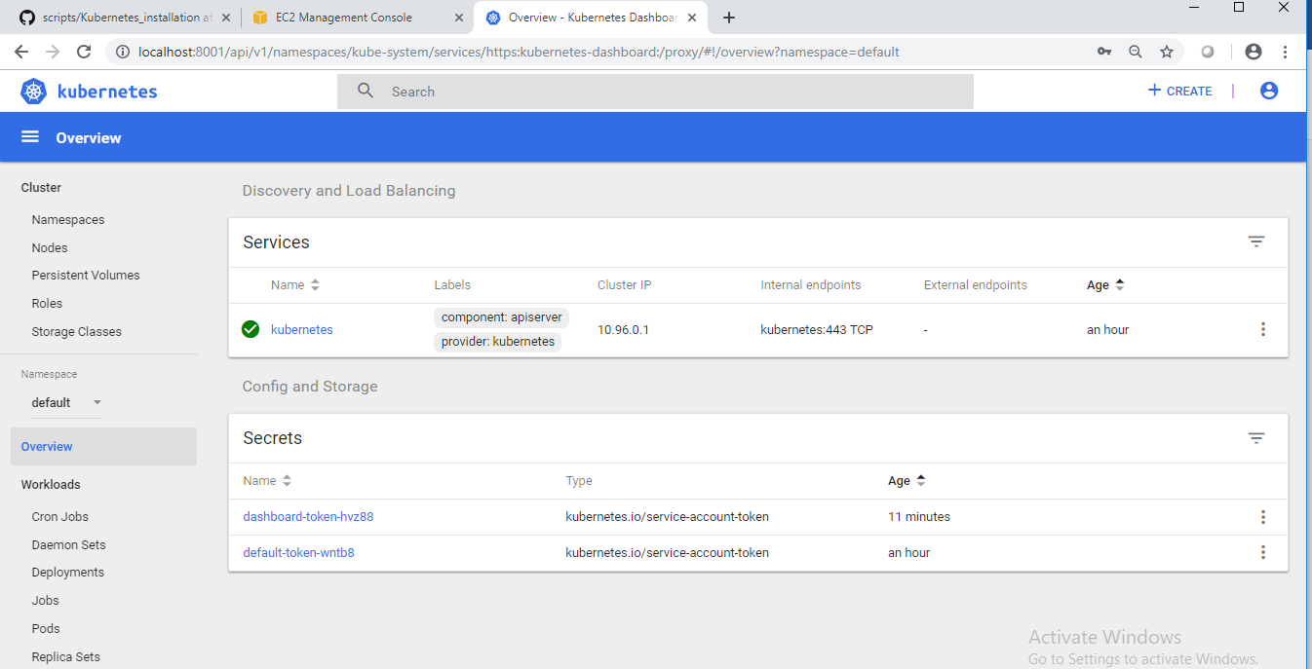

Now create one more VM configure the Master to Node

So I am taking one more Linux VM t2.micro

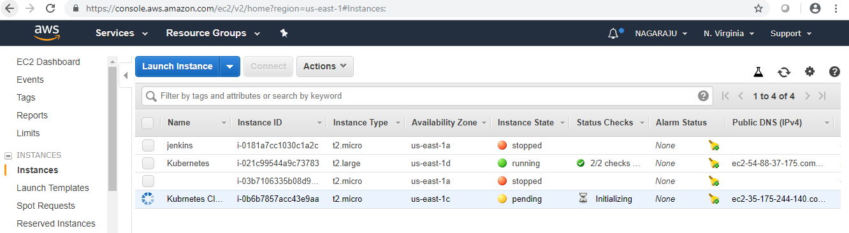

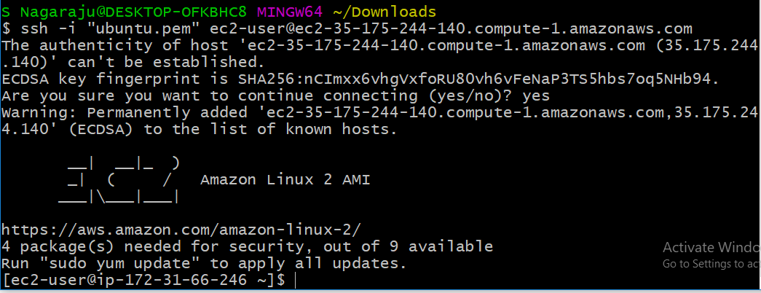

vi /etc/yum.repos.d/kubernetes.repo

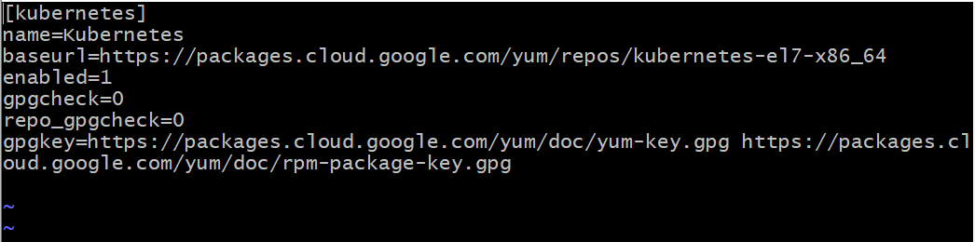

Here u install

kubeadm kubectl docker gcc 

start the service



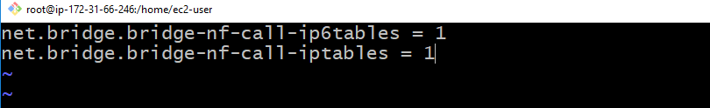

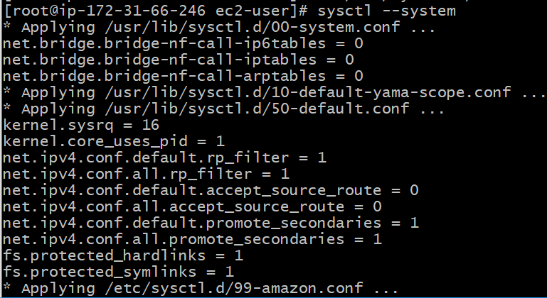

Now u run kube join command



It will configure the cluster in master

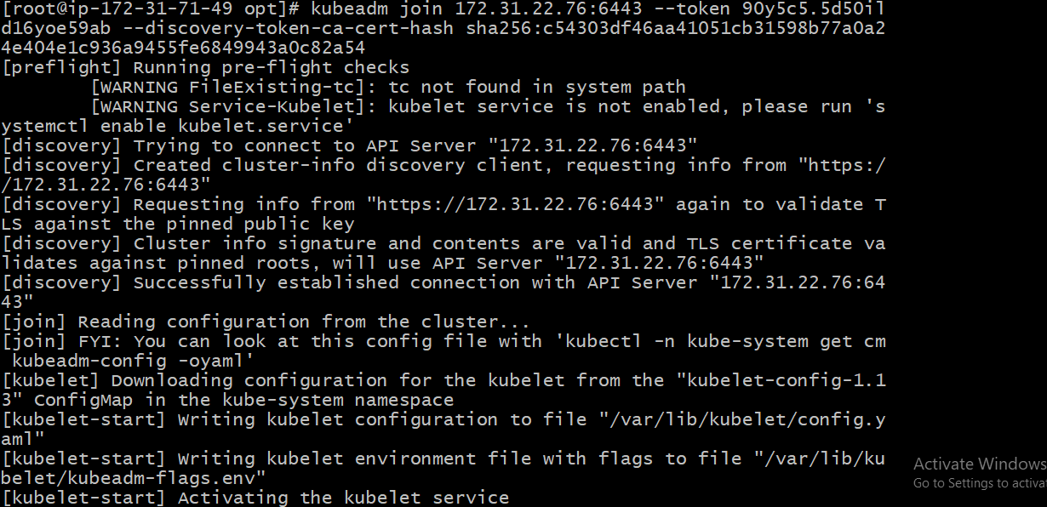

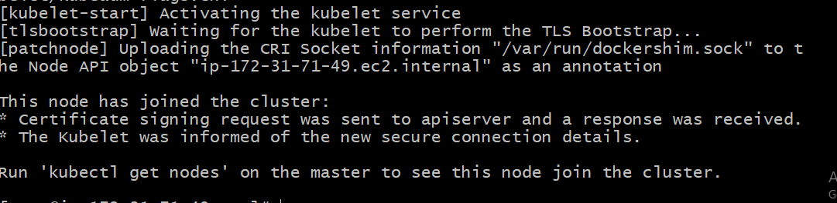

Configure Master and Node